Project Development Phase
Model Performance Test

Date | 18 February 2026
Team ID | LTVIP2026TMIDS34351
Project Name | Weather-Based Prediction of Wind Turbine Energy Output: A Next-Generation Approach to Renewable Energy Management
Maximum Marks

Model Performance Testing – Wind Turbine Energy Prediction
S.No | Parameter | Values | Screenshot
1 | Model Summary | Random Forest Regressor trained on wind turbine dataset using two input features: Wind Speed (m/s) and Theoretical Power Curve (kWh). The target variable is LV Active Power (kW). | –
2 | Data Split & Preprocessing | Dataset split into 80% training and 20% testing. Feature scaling performed using StandardScaler to normalize input values. | –
3 | Performance Metrics | R² Score = 0.8666 MAE = 201.10 RMSE = 477.07 | Scatter plot of Actual vs Predicted Power
4 | Model Validation | The model performance was evaluated on the test dataset using R², MAE, and RMSE metrics. The results indicate good predictive performance with strong correlation between actual and predicted values. | 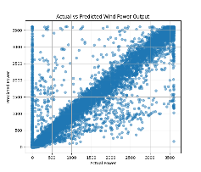
5 | Hyperparameter Tuning | The number of estimators (n_estimators ≈ 150) was adjusted experimentally to improve model performance. The final model was selected based on better R² score on validation data. | –
6 | Final Observation | The trained Random Forest model is able to explain approximately 86.6% of the variance in wind power output, showing that it is suitable for wind energy prediction applications. | –

